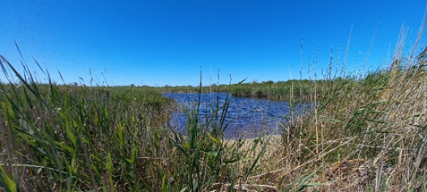 | 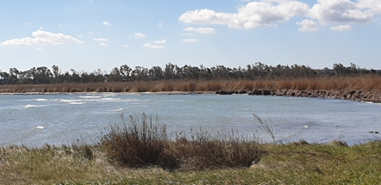
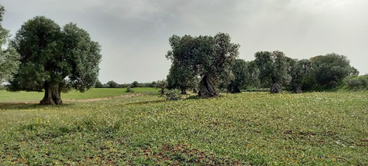 | 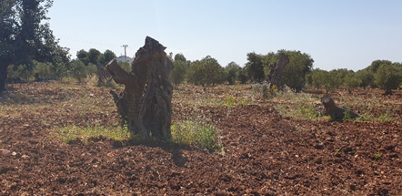
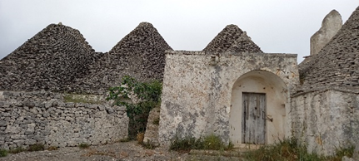 | 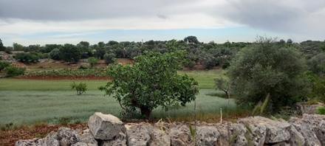

RISE – ATTER Autumn School 2023 (RAAS)
‘Agroecology participatory evaluation and its role in territorial food systems transition’

2nd - 6th October 2023 at CIHEAM Bari, Italy + 1 pre & 1 post online sessions

Co-organised and delivered in collaboration with Schola Campesina, LAG Alto Salento 2020 and the coordinating group for ATTER 2023 school edition

Concept note
Context & general approach
one Place,
one Tool,
multiple Sides

The agroecology participatory evaluation is the core focus of RISE ATTER Autumn School (RAAS) 2023. While agroecology is a comprehensive concept making visible the interconnectedness between the components of the food systems, the territorial level is the scale where these linkages are more easily captured and where a participatory evaluation has the greater potential to guide agri-food systems transitions.
The RISE ATTER Autumn School 2023 will enable participants to meet the reality of a territory in agroecological transition - Alto Salento, Puglia, Italy, one of the 16 territorial case studies of ATTER project - and take actively part in the evaluation of this territory in terms of agroecological characterisation (STEP 1), and sustainability performance (STEP 2), using the Tool of Agroecology Performance Evaluation (TAPE).

A systemic approach to agri-food systems is increasingly recognized as the complex and unavoidable approach to address the multiple challenges of our societies related to agriculture and food. Agroecology, as defined by the HLPE, FAO, and the Nyéléni Declaration, is a conceptual framework that is intrinsically systemic. Considering agroecology in a territory in transition will be an opportunity to explore the linkages between different dimensions of food systems and to discuss the relevance of appropriate assessment frameworks that would capture the complexity while enabling the transition.

As a region blessed with natural resources, agricultural historical landscapes, valuable rural architectural and cultural heritage, for the past two decades and more, Alto Salento has largely embodied EU Rural Development policy discourse about multifunctionality, agri-ruralism and nature conservation. Some actors’ concerns for the touristification drift now co-exist with a shared scaring threat. Indeed, the area, like others in Apulia region, is today struggling against a major natural and human crisis due to the spread of the deadly Xylella Fastidiosa pathogen that is ravaging century-old olive groves, a unique trait of the local landscape. Farmers are in dismay trying different remedies to save their trees and strategies to cope with the disaster, while different ideas about intensification vs agroecological and creative visions of the future are being discussed … quite an intriguing and thought-provoking place to develop a multi-sided understanding of complexity.

Objectives of the school
Participants to the school will:
- learn about the rationale and practice of the Tool of Agroecology Performance Evaluation (TAPE) evaluation process
- develop reflexive, critical thinking about the role of evaluation in territorial agroecological transitions through their own hands-on experience of the TAPE evaluation approach
- contribute to the characterization and analysis of ATTER-Alto Salento case study through exchange with local farmers and stakeholders

Pedagogical approach & key contents
The school package includes a one-week face-to-face module (from 2nd to 6th Oct 2023) that will be preceded by an introductory online seminar and overview session (in Sept 2023) and followed by a post-school online reflection and evaluation session (in Oct 2023).

In the one-week face-to-face module the learning process is guided by the search to develop a critical reflection on the addressed topics, continuously enriched by the group discussion and the field visits. All along the training, the participants will be sharing their reflections, bringing their particular experience, and progressively build a common and critical understanding of the different dimensions of the evaluation of agri-food systems.
The school method combines theorical and practical sessions, allows the participants to connect the practical exercises (TAPE test within the LAG) and the visits to the Alto Salento reality to the theoretical aspects of evaluation and agri-food transitions. Each theoretical session will be thought around collective reflections between participants nourished from the actions of implementing TAPE and observations from the field visit, specific inputs by invited speakers and from literature and educational material (to be shared to all participants prior to the training).
In particular, the participants will exchange and reflect on the following topics: i) agroecology as a framework to guide transition toward more sustainability; ii) different approaches to assessment and the type of transition they promote for territorial agri-food systems; iii) the role of systemic and context-sensitive approach of evaluation and the opportunity of self-managed and participatory tools; iv) the strengths, weaknesses, opportunities and threats of TAPE.

The horizontality of the learning process - where participants learn from each other’s while also receiving specific inputs from external experts - is the basic ground of the methodology used. As the sharing requires a trust environment and a good atmosphere, friendly and informal spaces and rooms will be used. Every participant, with its unique profile, will have an active role to play in the sharing and the building of a common understanding.
To ensure that each participant is given opportunities to make a full-immersion, meaningful school experience, besides two TAPE experts, the facilitation team will also include a third person that will specifically act as a learning enhancer.

When
RAAS 2023 will take place from Monday 2nd to Friday 6th October 2023.

Where
Participants will be hosted at the at CIHEAM Bari Cosimo Lacirignola campus, located in via Ceglie 9 - 70010 Valenzano (BARI), Italy.
Contact person: Patrizia Pugliese: mob. +39 329 6908694 | email: pugliese@iamb.it

Co-organisers
RAAS 2023 is co-organised and delivered by CIHEAM Bari in collaboration with Schola Campesina, LAG Alto Salento 2020 and the coordinating group for ATTER 2023 school edition.

For whom
For logistic reasons we have space for 12 participants identified within ATTER-network. Participation to the school is to be funded by the sending institution that is expected to cover the participant’s travel and full board (accommodation and meals) costs. Funding through secondment may be considered.

Are you a practitioner, researcher or PhD-student at one of the partners of the ATTER-network and interested in participating? Please do tell us a few things about yourself here below before Friday Sept 8th 2023.

Name: | Age: | Gender:
Role in your institution: Ph.D, researcher, research staff, other (please specify)

Why would you like to participate in this Autumn School?

What is your experience, if any, with participatory evaluation?

Do you have any knowledge of the Italian language? (please specify)

Thank you for your interest and looking forward to meeting you in Bari in October!

Contact persons to send the application form
- Barbara Van Dyck ad5037@coventry.ac.uk
- Danièle Magda daniele.magda@inrae.fr
- Patrizia Pugliese pugliese@iamb.it

